Coding Practice On Python

1. Accept 2 numbers from the user find out sum of them ?
2. Accept 2 numbers from the user swapping of two with and without using third variable ?
3. Accept 2 numbers from the user find out (a+b)^2
4. Accept radius of the circle find out area of Circle ?
5. Accept radius of the circle find out circumference of circle ?
6. Accept Base and height of triangle find out area of triangle ?
7. Accept length and breadth of rectangle and find out area of rectangle ?
8. Accept principle amount , rate of interest , time and calculate simple interest ?
9. Accept Salary from the user find out HRA, TA, DA and net salary

HRA is 10% on salary, TA is 5% on salary and DA is 3% on salary?

1. Accept weight and height and calculate BMI

Using Conditional Statements

1.Accept a number from the user find out the given number is +ve or –ve ?

2.Accept a number from the user find out the given number is odd or even.?

3.Accept year from the user find out the given year is leap or not with and without using calendar module.

4.Accept 2 numbers from the user find out biggest in 2?

5.Accept marks from the user print pass if marks is >34 else Fail.

6.Accept gender from the user print male iff the given char is m or M else print Female.

7.Accept gender from the user print male iff the given char is m or M, print Female iff the given char is f or F . else third-Gender ?

8.Accept 4 numbers from the user find out biggest in 4 ?

9.Accept 5 numbers from the user find out smallest in 5 ?

10.Accept service number from the user print the following Service name . if sno is 101 print Fire. If sno is 100 print police, if sno is 104 print medical, if sno is 108 print EMRI else Invalid

11.Accept gender from the user print male iff the given char is m or M else print Female. Using match case.

12.Accept a char from the user find out the given char is vowel or not?

13.Accept service number from the user print the following Service name . if sno is 101 print Fire. If sno is 100 print police, if sno is 104 print medical, if sno is 108 print EMRI else Invalid using match case.

14.Mini Project using Conditional Statement

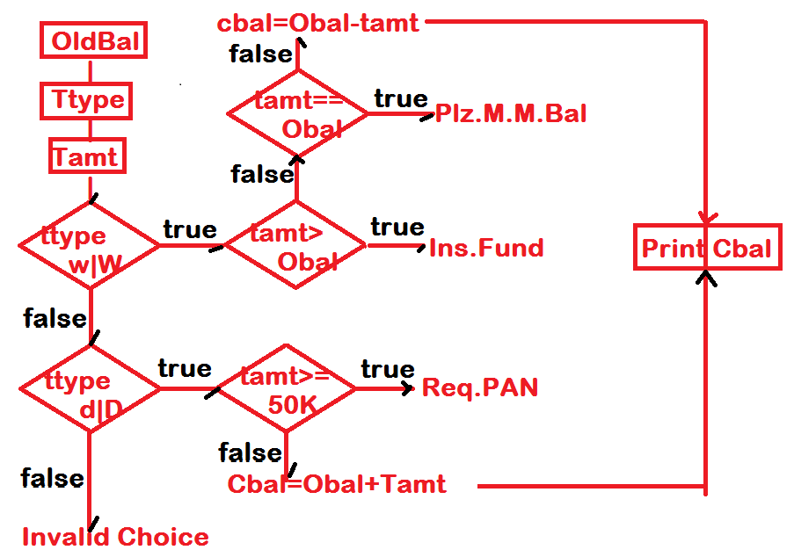

Using Control Statement(s)

1.program to generate 1 to 10 using While ?

2.generate Evens from 20 to 90 using for….?

3.Generate squares of evens between 2 to 20 ?

4.generate A TO Z using while loop ?

5.Accept a number Generate sum of nature numbers 1+2+3+4……+n = ?

6.Accept a number find out factorial value of the given number ?

7.Accept a number from the user find out sum of digits in the given number ? Eg: 123 output: 1+2+3=6

8.Accept a number from the user find out sum of first and last digit in the given number Eg: 123 out: 1+3=4

9.Accept a number from the user print given number is reverse ? eg: 124 output: 421

10.Accept a number from the user find out the count of digits in the given number Eg: 123 output: 3

11.Accept a number from the user find out the given number is prime or not ?

12.Accept a number from the user find out the given number Armstrong or not ?

13.Accept a number from the user print all prime numbers between 1..n

14.Accept a number from the user print all possible palindrome numbers from 1….n

15.Accept a number from the user find out the given number is strong or not ?

16.Program to generate the following output?

\*

\* \*

\* \* \*

17.Generate the following output ?

\* \* \*

\* \*

\*

18.Generate the following output using while loop ?

A

AB

ABC

ABCD

19.Generate the following output?

A

BB

CCC

20.Generate the following output?

1 2 3 4

5 6 7 8

9 10 11 12

21.Generate the following output using single loop?

1 5

2 4

3 3

22.Generate the following output using single while loop ?

1 5

Sssit kphb

3 3

Sssit kphb

23.Generate the following

1

\* \*

3 3 3

\* \* \* \*

5 5 5 5 5

14.Generate the following

1

1 \*

1 \* 3

1 \* 3 \*

1 \* 3 \* 6

15.Generate the following

\*

\* \*

\* \* \*

16.Generate the following using while loop

\*

\* \*

\* \* \*

\* \* \*

\* \*

\*

17.Generate the following

A

\* \*

C C C

\* \* \* \*

D D D D D

18.Generate the following

00 01 02

10 11 12

20 21 22

19.generate the following

\* \* \* \* \*

A A A A

\* \* \*

C C

\*

20.Generate the following

\* \* \*

\* \*

\*

21.program to print The following

$

$ $

$ $ $

22.

\*

\* \* \* \*

\* \* \* \* \* \* \*

\* \* \* \* \*

\* \* \*

\*

22.

\*\*

\* \*\* \*

\* \* \*\* \* \*

23.

\*

\* \* \*

\* \* \* \* \*

Using List manipulations

1.Findout all duplicates Existed in the list collection and Write then into another list

L1=[1,2,3,3,2,]

L2=[2,3]

2.Code to remove all duplicates from the list without using set collection?

Eg: l1=[1,2,3,4,5,2,3,7]

Output: 1,2,3,4,5,7

3.Code for deleting an Occurrences of Specified object from the list?

L1=[10,20,30,10,40,50]

Input: 10

Output= [20,30,40,50]

4.Sort the elements Existed in the collection without using sort( ) or sorted function.

L1=[40,50,60,10,20]

L2=[10,20,40,50,60]

5.Extract Common Objects are Existed in the two list collection without using set class method intersection

A=[1,2,3,4,5]

B=[3,4,5,6]

C=[3,4,5]

Coding Test on tuple:

* Code for inserting an item at given index
  + T=(10,20,30,40,50)
  + Pos=2
  + Item=999
  + Output: t=(10,20,999,40,50)
* Write application for Deleting an item Existed at given index

t=(10,20,30,40,50)

pos=2

Output: t=(10,20,40,50)

* Program For concatenation of two tuples without using concatenation operator
  + A=(10,20,30,40)
  + B=(40,50,60,70)
  + Res=(10,20,30,40,60,70)

Coding On String

1.”welcome to sssit computer education kphb Hyderabad”

Count the words and characters are existed in the above string

2.”have a nice day my dear friend”

Print all the words starts with letter d

3.”Have a nice day my Dear Friend”

Print all the words which are existed at even positions

4.”Have a nice day my Dear Friend”

Print all the words in reverse existed in the odd position

5.”Have a nice day my Dear Friend”

Print all the words which contains second char is a

6.Accept a String from the user find out the String is palindrome or not ?